|  |  |
| --- | --- |
| **Title** | **Do large red blood cells increase the risk of vision loss from Leber Hereditary Optic Neuropathy (LHON)?** |
|  |
|  |  |
| **Principal Investigator** | **Professor David Mackey** |
| **Location** | **Centre for Eye Research Australia** |

**Child Information Sheet**

**Why am I being asked to be in this study?**

The eye is made of three parts (Picture of eye)

• A light focussing part at the front (cornea and lens).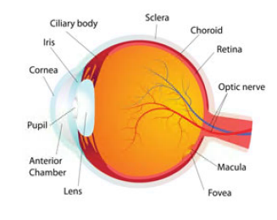

• A light sensitive film at the back of the eye (retina).

• A large collection of communication wires forms a cable (optic nerve) that goes to the brain.

In Leber Hereditary Optic Neuropathy (LHON) the cable is damaged making it difficult to see clearly. It is harder to see faces and read signs or books.

In families with LHON, there may be some people who have this problem with their vision whilst other people in the same family can see well. Doctors are not sure exactly why this happens.

Your blood can give doctors and scientists clues about your health. A blood test looks at the different cells in the blood. Looking at blood cells in people who have good vision and those who don’t may help us find out if there are ways to help people protect their eyes and vision.

If you had a blood test before, we would ask your parents or the person looking after you to answer some questions about you, your eyes and information about the blood cells.

**Do I have to be in this study?**

You do not have to be in this study. It is up to you whether you take part.

Together with your parents or the person who looks after you, you should decide if being in this study is the right thing for you.

**How long will I be in the study?**

It will take less than 10 minutes for your parents or person looking after you to answer some questions about you.

**What will happen to me?**

As part of this study, we will ask information about you:

* your age and health of your eyes
* information about your blood cells

**Who will get my information?**

People working on this study will collect information from you and other people who might have the condition Leber Hereditary Optic Neuropathy (LHON)

We will use this information to write a scientific report about the overall results of the study. Your name will not be on the report. You and your parents or person looking after you can choose to receive a copy of this report and/or newsletter via e-mail.

**What if I have questions about the study?**

If you have any questions, you can talk to us, the study team.

You can call the study managers Lisa Kearns or Sandra Staffieri on +61 3 9929 8360 or email them at sstaffieri@cera.org.au; lkearns@cera.org.au.

You can also ask your parents to talk to us.