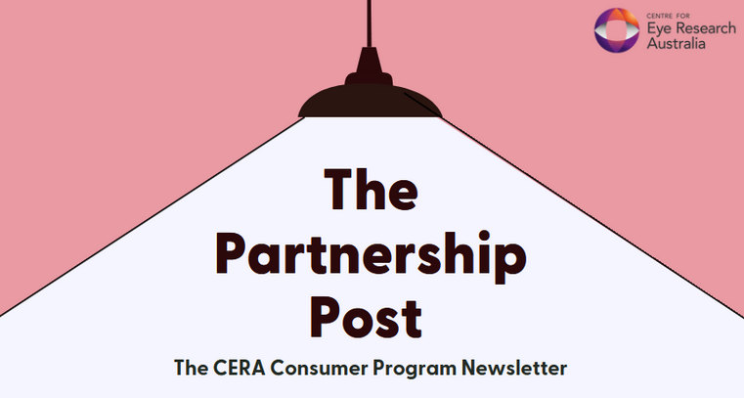

[](https://www.cera.org.au/wp-content/uploads/2025/08/Newsletter-audio-06-Aug-2025.mp3)

Welcome to the first edition of The Partnership Post - the bi-yearly newsletter specifically for members of our Consumer Program, which gives you updates on consumer-researcher partnership activities happening across the Centre for Eye Research Australia (CERA) and Cerulea Clinical Trials.

In the last month I tried to touch base with each of you. For those I was able to contact, I gave on update on our activities, asked about your main interest areas as a consumer, and spoke to you about our focus on creating research partnerships at the same time that project partnerships are taking off.

As a group, I'd love us to create a guide that outlines how we hope partnerships will work whilst building education and awareness of consumer involvement across CERA projects and Cerulea Clinical Trials. Our researchers are always eager to learn about the valuable ways our consumer partners can contribute to their research. I'm also keen to develop with you, resources and educational resources for both consumers and researchers to help support them on their partnership journey. Please reach out to me if you are interested in being involved in developing this guide and/or the educational resources.

And lastly, we've called this newsletter The Partnership Post, but it’s **your** program and **your** newsletter, so if you like the name as it is, or have any good ideas on what this newsletter should be called, please let me know. As well as this, recent interactions with program members have raised a sticking point around the term 'consumer' with a preference for 'lived experience advisor/consultant or collaborator'. Feedback on how we define our group is welcome.

You can reach me on [consumerprogram@cera.org.au](mailto:consumerprogram@cera.org.au) or 03 9959 0113, with Monday to Wednesday's the best days to reach me on between 9am and 4pm.

Thank you so much for putting your hand up to be a member of our Consumer Program. I look forward to working with you all.

Warm wishes,

**Fleur O'Hare**  
Consumer Involvement and Advocacy Lead  
Centre for Eye Research Australia



[**Inherited Retinal Disease Patient and Family Day**](https://events.unsw.edu.au/event/2025-inherited-retinal-disease-patient-and-family-day) | 25 October | 9.30am - 4pm | [Vision Australia Kooyong,](https://www.healthdirect.gov.au/australian-health-services/healthcare-service/kooyong-3144-vic/vision-australia-kooyong/general-counselling/d7c2486e-742f-6e2b-cf53-816f02a6eca2) 454 Glenferrie Rd, Kooyong, VIC | This event offers a unique opportunity to learn about the latest developments in IRD research, including cutting-edge treatments, clinical trials, and the future of gene and cell therapies

**Consumer Information Sessions** | 10 November at 1pm (online) 12 November (in-person) 10.30am | Zoom link below for online session | Level 10, 200 Victoria Parade in East Melbourne | Our consumer partners have an active role in contributing to the conversation around research direction. These information sessions will highlight some of the research that is happening at CERA, and reviewing grant applications can be a good way to get involved in the early planning stages of a project.

[**Click this link to join the meeting 10 Nov at 1pm online**](https://unimelb.zoom.us/j/84401628359?pwd=Ch2qp1z9rPB5x6X0uOlAw8KZMTCNIR.1)

If you prefer to join the meeting on the 10 November via phone, please call 03 7018 2005 and enter the meeting ID 844 016 283 59.

If you are attending the in person on Wednesday 12 November at 10.30am, please let Fleur know so we can let the ground floor staff know to expect you: [consumerprogram@cera.org.au](mailto:consumerprogram@cera.org.au)



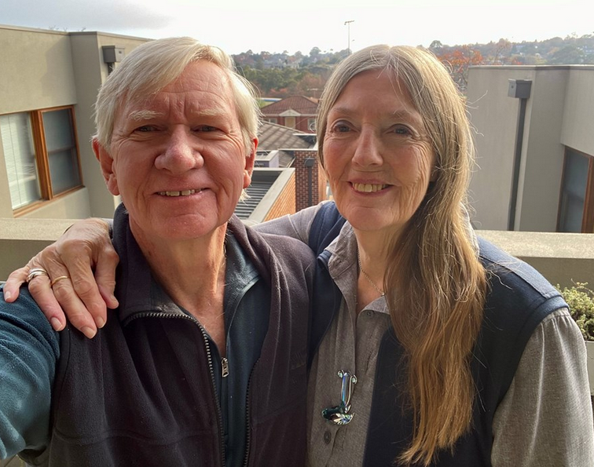

As part of their ongoing journey with CERA, Carmel McNaught and David Kennedy both regularly engage in events and research opportunities. Carmel has recently become a member of the Consumer Program at CERA and has expressed interest in helping to develop the education materials for consumer partners and researchers. Education has been an important part of Carmel’s life, and she brings skills and expertise in this area to her consumer role at CERA.

Carmel looks forward to providing feedback on research design, ensuring materials are accessible, and helping translate research findings into understandable content.

Carmel and David also had a chat to us last month about being regular donors to CERA. Find this article below.

[](https://www.cera.org.au/ongoing-support-makes-a-world-of-difference/)

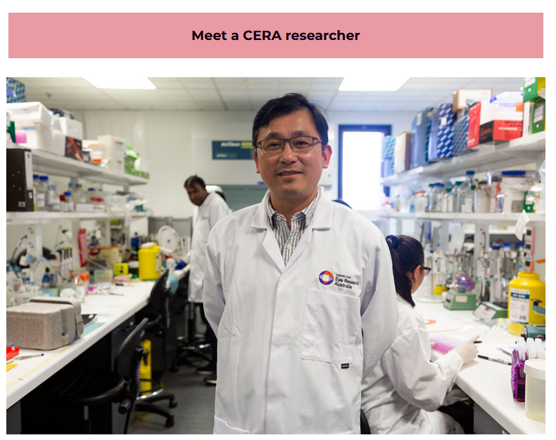

Associate Professor Guei-Sheung (Rick) Liu is the Principal Investigator, Head of Genetic Engineering Research and leads CERA’s genetic engineering research, focusing on using advanced gene technology to improve treatments for eye diseases.

](https://www.cera.org.au/progressing-gene-therapy/)



Karen Brown, Lisa Lombardi and Lauren Moussallem, members of the Cerulea Clinical Trials team, are leading a project which is trialling a new tool to better understand the impact of vision loss. They are looking for volunteers to participate in this project. If you are interested, please reach out to Fleur via the consumer email and your details can be forwarded to the team.



Our Annual Report is now available to download to read or as an audio format for you to listen to.





Top of Form