Accessibility Guide for CT:IQ InFORMed vision accessible PICF template.
This document sets out general guidelines for text documents to be enhanced for accessibility. There are five sections.
- Section 1 contains tips for presenting the information, the order of sections and general accessibility tips.
- Section 2 sets our specific recommendations for presenting the information and includes considerations regarding headings, font, tables and bullet points. It also provides tips for presentation of consent options and signature boxes for written informed consent procedures.
- Section 3 outlines how to convert your Word file into other formats including PDF.
- Section 4 is a complied list of additional tools and resources for creating accessible documents.
- Section 5 lists the research partners involved in this work.

Section 1: General recommendations
- Document format is critical to how accessible the document is for the recipient. Generally, an electronic Word format (docx) is generally the file format preference to enable manipulation of the document e.g., make adjustments or conversions, and access the information using assistive technology.
- Conversions include magnifying the screen, increasing the font size and converting the background to a dark shade with the writing in a high contrast lighter shade. For example, black background with white writing may be preferred as this may reduce the glare perceived from white backgrounds. As such, it is good practice to have all text in one colour throughout the document as it makes converting the background and text more uniform.
- Noting above, the blue text boxes in the standard template have been removed and replaced. Text boxes are not accessible for conversions or screen reader access.
- Screen reader software and voice over applications access text information and covert text to speech. They rely on navigating the document headers and will only read text and alternative text. Thus, screen readers will not read text in text boxes or text embedded in images or graphics.
- Accessibility design features can be guided by using Microsoft Word’s built-in accessibility checker, accessed through the design toolbar.
- Accessibility extends to language, where descriptions and points need to be stated plainly and concisely. Consideration to the term “masked” rather than “blind/blinded” could also be made. See InFORMed Principle 4.

Section 2: Specific recommendations for creating accessible Word formats
The InFORMed vision accessible PICF template has enhanced accessibility features. Please note, if you stray from the template, there are no assurances that the document will be accessible. Once the template has been filled with study-specific information, it is strongly recommended that the document be reviewed for accessibility with consumer research partners.
The sections that are to be filled with study specific information are presented in round brackets. Square brackets provide instructions, and this information is to be removed before ethics submission. Brackets replace the ‘greater than’ and ‘less than’ symbols and black text replace coloured text in this template version. Capitals and italics are avoided.
The following tips are to ensure that your text or print documents are engaging and accessible.

Section 2.1: Font Size
- San serif fonts are recommended because they are easier to read and see. This is an example of Sans Serif Font called Aptos in font size 14.
- To improve both readability and visibility, the main body font size should be font size 14 minimum. For a large print version, the main body of the text is recommended to be 18 and above. See Section 2.3 below for suggested sizes.

Section 2.2: Headings
It is vital that headings are created using the ‘styles’ toolbar options in Microsoft Word. This is to ensure that headings can be signposted in the document. It also means that screen reader users and people that prefer to convert text to speech can navigate the sections of the document with more ease.

Section 2.3: Style Format
Recommended heading style and sizes for a standard version are shown below:
Main Heading 1 font size 18 (minimum)
Subheading Heading 2 font size 16
Body Text Section Heading 3 font size 14
Recommended heading font sizes for a large print version are shown below:
Main heading 1 font size 36
Subheading Heading 2 font size 24
Body text and Section Heading 3 font size 18

Section 2.4 Line Spacing
- The space between lines of text needs to be adequate. If the space between lines is too narrow, the print can be difficult to read. Lines of text may appear to merge with the text on the lines above and below, making it difficult to recognise word shapes.
- For a standard document with font size 12 and above, the recommended minimum line spacing is 1.2. This will assist readers in moving their eyes more easily to the next line of text (see Round Table guidance, Section 4.1). The vision accessible PICF template complies with this line spacing requirement. The international accessibility standard (see WCAG, Section 4.1) recommends 1.5 line spacing, however the Round Table for print disability guidelines recommend lines spacing of 1.2. This is due to 1.5 being excessively large for large font documents, particularly those over font size 20.

Section 2.5: Bullet points
- Bullet points are effective in presenting concise key points. However, don’t overdo the bullet points. Generally, high contrast filled dots are easier to see than dashes or unfilled circles.
- The option to increase the size of the bullet points is available through the bullet point menu. To do this select ‘define new bullet point’ and select the size of the point under font option.

Section 2.6: Tables
- Ensure you have an equal number of columns to rows. Specifically, no merged or split cells.
- Tables can be navigated by screen readers with bookmarks added. Bookmarking is coding the table for rows and columns. To do this you will need to:
- Go to the first cell in your table and place your cursor in this cell.
- Go to the “insert” menu and find the bookmark icon under links.
- Type in “Title” if both your rows and columns have titles, “ColumnTitle” or “RowTitle” if titles are in either. See Figure 1 below.
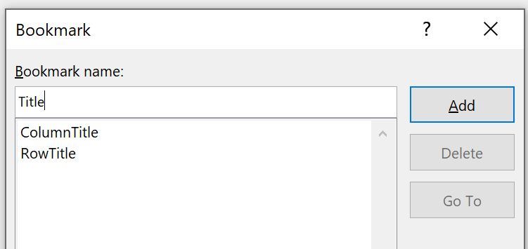
Figure 1. Codes shown for adding bookmarks to tables.
Note: You can also click on this image and “view alt text” to show an example of alternative text. Also note that Figure 1 is aligned with the left margin of the page and is formatted “in line with text”. For further information on image and table accessibility, please refer to Section 4.
- Ensure that column headers appear at the top of the table on each new page. To do this you can navigate to the accessibility tab in Microsoft Word, select ‘set table’ and select the appropriate header e.g. column headers only.
- The alternative way to ensure that table headers appear on each page is to navigate to Table Properties or table layout menu and select repeat header rows.

Section 2.7: Colour and Contrast
- Good contrast between the text and the background is important for legibility. You can check colour contrast using a checker such as WebAIM [https://webaim.org/resources/contrastchecker/].
- To help ensure your document is legible for people with colour vision deficiencies it is recommended to use black text on white background. This provides the highest contrast. This has been applied in the accompanying PICF template.
- Some readers may opt to convert the text and background colour if the document is offered in a digital format. They can select to change the text to a light shade, such as white or yellow, and change the background to black or dark grey. Converting can assist with reducing glare.
- Choose the same colour for the text throughout so there is uniform colour contrast. It helps with text conversions and makes it easier for someone to see and adjust to one colour rather than several.
- Use only styles to select colour instead of assigning colours directly to text. This allows readers to change colours if required

Section 2.8: Information in Headers and Footers
- Headers and footers will not be read to the reader using screen reader technology. Consider whether information is useful for all readers before placing it in the header or footer areas of the document.

Section 3: Converting your Word file to other formats
To copy the heading and format structure from Word to PDF format, perform the following steps:
- Select PDF under ‘save as’ file format.
- Select options and ensure that heading structure and document tags for accessibility are chosen. See Figure 2 below.

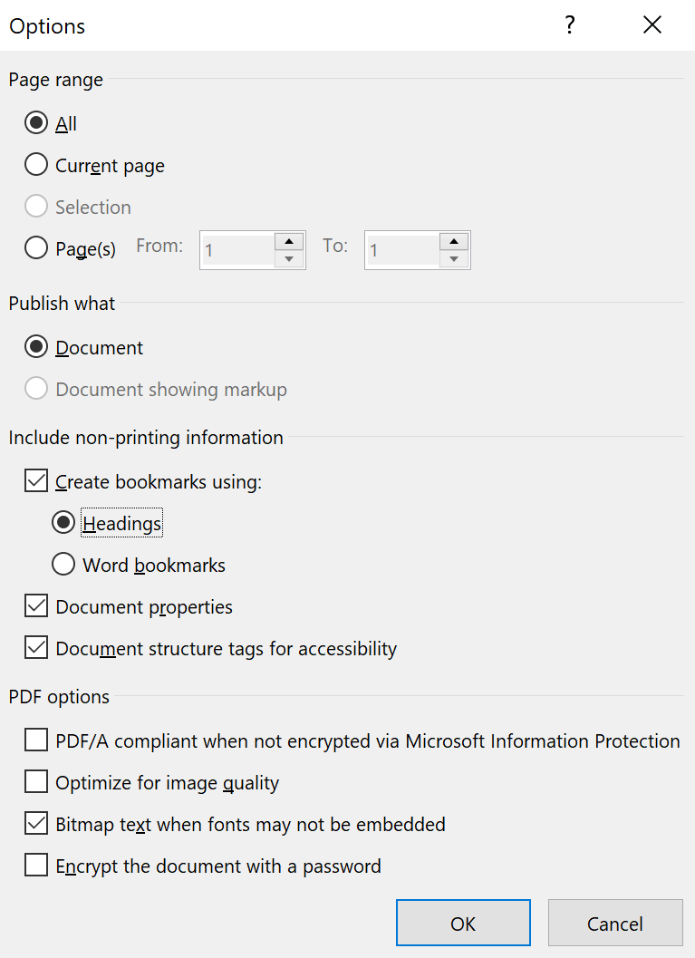
Figure 2. Options to ensure accessibility features are copied from Word format to PDF.

Section 4: Additional tools and resources.
This is a selection of tools and resources to assist with producing accessible print materials. These links also contain guides for producing accessible images and graphics. A link to the international digital accessibility guidelines (WCAG) is also available.

Section 4.1: links to pages on general print document accessibility
- Round Table guides for producing accessible materials
- Disability Gateway guides for producing accessible print and digital documents
- Web Content Accessibility Guidelines (WCAG) international standard

Section 5: Acknowledgement of Research Partners
This work has been led by Fleur O’Hare and David Foran with the valuable contribution of the following consumer partners in this research (in alphabetical order):
- Caitlin Alsop
- Daniel Talko
- Debra Simons
- Grace King
- John Paul Cruz
- Kevin Lee
- Micheal Burmeister
- Michelle O’Brien
- Perry Cunnigham
- Shane Somerville

Appendix: Make your documents vision accessible

Why is this important?
Vision impairment is one of the leading causes of print disability. According to Vision Australia, print disability affects approximately 18% of the population. This represents around 4 million Australians. One way to reduce this challenge is to make print documents more accessible. The principles above discuss accessibility in terms of language. Below are specific points to ensure documents are optimised for all vision levels and abilities.

How can I make my documents more vision-accessible?
A vision accessible version of the InFORMed PICF template is available with an accompanying accessibility guide. The key features of this version are the following:
- Recommendations regarding formatting to enable use with assistive technology.
- Recommendations regarding style and font size for both a standard and large print version of the template.
- Guidance on how to bookmark tables and create alternative text for images.

Where can I read more about this?
- Vision Australia - What is Print Disability
- Round Table guides for producing accessible materials
- Disability Gateway guides for producing accessible print and digital documents

