Partnership Post
Welcome to our second edition of the Partnership Post, a newsletter to keep you updated on what’s happening across the Centre for Eye Research Australia (CERA).
Dear CERA supporter,
CERA’s Consumer Program emerged out of a drive for best practice approaches to our research, and it’s led by those of you who it affects most in the community with lived experiences of vision loss and blindness.
Your involvement is critical to ensure that our research addresses real-world needs and priorities, and we are so thankful that you are involved and collaborating with us. We've done a lot of great work since we started.
In this edition I share with you how three of our members have been getting more involved in our research. I also share with you our 2025 Impact report - which showcases how donors supported and impacted our work last year.
As always, you can reach me on consumerprogram@cera.org.au or (03) 9959 0113, with Monday to Wednesday's the best days to reach me on between 9am and 4pm.
Warm wishes, Fleur O’Hare Consumer Involvement and Advocacy Lead

Working well together
Sixty dedicated members of the community are making sure research at CERA meets the needs of people living with vision loss and blindness.
CERA’s Consumer Program has been established to make sure that we implement and undertake research that meets the priorities of the community it hopes to benefit from it.
The program integrates the insights, experiences and perspectives of people living with eye diseases directly into our research processes - producing and building on research that is not only scientifically rigorous but also relevant and beneficial for the wider community.
An essential feature of the program is the Consumer Advisory Group, which ensures that the voices of those with lived experiences of eye disease are not only heard, but actively help shape the direction of our research.
In 2025, 40 consumer research partners - joined by advocacy organisation members and representatives of our researcher community - participated across 9 projects, and 13 members are now embedded into CERA’s research teams.
The ethos of the Consumer Program extends beyond the work at CERA.
“We want to do what is best for those we are all trying to help and sharing resources we have developed on our website for everyone to access is a great start,” says Fleur.

It’s a sentiment echoed by Consumer Advisory Group committee member Honorary Professor Colleen Lewis, who has lost vision in her left eye from dry AMD and has wet and dry AMD in her right eye. Honorary Professor Lewis, whose research focuses on the politics of accountability at the Australian National University (ANU), says that both researcher and consumer have a common goal.
“We want to find cures for eye diseases. We all want to ensure that CERA’s research addresses real-world issues whilst enhancing the accessibility and relevance of our findings, so that everyone has a chance to benefit from it” says Colleen.
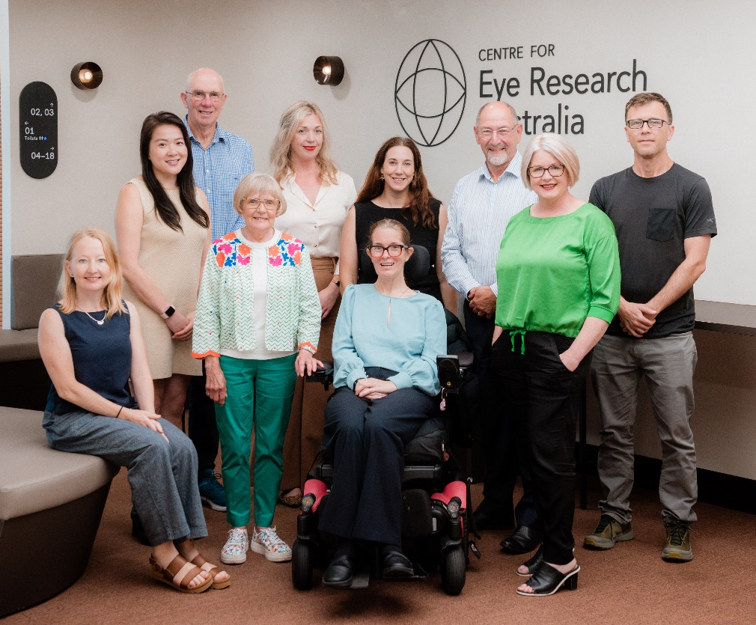
Photo showing members of the Consumer Advisory Group with Colleen pictured third from left. Click on the alternative text for all names of people shown.

Lani Dinh features at CERA’s 17th Annual Crock Lecture
Lani Dinh was diagnosed with glaucoma in her early 30s - just as her first son had turned two.
By the time she was diagnosed, significant damage to her eyes had already occurred.
“I had to grieve the life I once knew, while learning to rebuild as a new woman and rediscover my strength.”
However, it also revealed a resilience that Lani didn't know she had.
The condition led her towards community, being involved in sport and advocacy.
“I live with glaucoma, but I refuse to live small,” she says.
Lani became a member of CERA’s Consumer Program when she began seeking a deeper understanding of glaucoma research and future developments.
Her involvement in the group, which included speaking at CERA’s Annual Gerard Crock Lecture, has made her feel less alone.
“If sharing my journey can help humanise research and support future progress, I am honoured to contribute” says Lani.
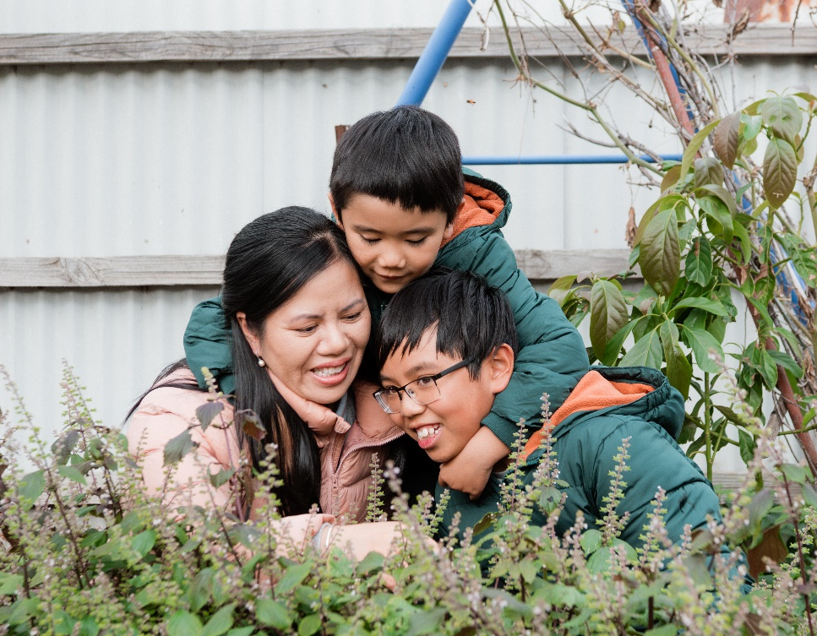
Photo: Lani Dinh with her two sons.

Steffenie Langby takes on co-investigator research role
Collaboration between research and consumers is aiming to transform diabetes screening nationwide.
A camera powered by Artificial intelligence (AI) able to predict the onset of diabetes - as well as cardiovascular disease - has been the goal of research undertaken by CERA’s Head of Ophthalmic Epidemiology Associate Professor Lisa Zhuoting Zhu.
With Dr Wenyi Hu, she is currently working towards implementing this innovative technology into primary care settings where it could reduce the barriers to accessing care.
But they are not doing this alone, with Steffenie Langby - who has a common, early-stage form of diabetic eye disease - giving her time and expertise to the project.
“Steffenie has generously served on our advisory board for this project, providing invaluable consumer-informed insights in reviewing our grant application and helping shape the long-term vision of the program,” says Associate Professor Zhu.
“The beauty of incorporating a consumer voice like Steffanie’s in a grant application is that it grounds the project in lived experience. The project team also acknowledges the value of bringing a group of consumers together, with additional consumer involvement strengthening the research through diverse perspectives and real-world experience.
Steffenie has experience as a project manager and consultant in telecommunications in regional and remote areas – using her skills in these areas to further support the project.
“As a person with diabetic eye disease, I am so delighted to collaborate with CERA as we push to make a proven AI‑powered retinal screening system which detects diabetes early, available to all,” says Steffenie.
So far, Steffenie has advised CERA on the remote use of technology where access to the internet could be difficult and supported the writing of a grant submission.
Steffenie is adamant that more needs to be done to bridge the access gap for people living in remote communities stating, “It’s my hope that together we can introduce this technology across the country to reduce the burden of diabetes and its complications for all”.

Photo: Steffenie sitting with her dog Freya.
CERA’s Impact Report 2025
Our annual Impact Report showcases some of the achievements that CERA donors helped make happen in 2025.
